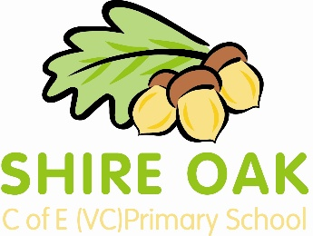

YR Thames Class Curriculum Newsletter
Spring 1 2015
Dear Parents and Carers, please find attached information about our learning this half term.
Personal, social and emotional: We will be building on the whole school learning about ‘Growth Mindsets’ to encourage facing challenges positively and persevering. We will also be starting philosophy to enable us to express our opinions and better understand others points of view.
Communication and language: Previously ‘show and tell’ helped us learn how to express ourselves through our interests. We will be replacing it with philosophy to build upon this learning and add more challenge. The children will make choices about questions without a ‘correct’ answer and justify their opinions.
Physical development: We will continue to develop physically in our outdoor area and through our regular outdoor learning sessions. In PE we will be learning about ball skills and aiming to have increasing control over objects when rolling, throwing, and catching.
Literacy: In phonics we are starting phase 3 of the letters and sounds programme. We will also be encouraging children to make attempts at writing words they are unsure of e.g. labelling drawings, writing lists and writing in our individual diaries that we started at the end of last term.
Maths: In maths we will begin by learning about teen numbers (11-20) and place value. We will then learn about 3D shapes and revisit 2D shapes through this. After this we will revisit addition and subtraction to become more secure in this important area. Finally, we will look at doubling and halving. We will also be starting our maths passports this half term with children working towards UK or Europe.
Our topic: The children have chosen the topic ‘machines’. They are very interested in robots and electricity and we responding to their interests and questions in our learning. We will also be learning about different types of machines and the power they use e.g. water, steam or human power.
Please see our class blog for more information about our learning: http://www.shireoakreception.blogspot.co.uk/
How you can help: We encourage you to be involved in your child’s learning by checking the maths and literacy posters in the class window. These will be updated every Monday with information about the learning that will be happening that week. However, please remember that the most important homework you can do is reading together regularly and practising phonics. Once the maths passports are sent home then working towards the targets is also important. Information will be given at the maths parents meeting on the 28th January at 6pm.
We are always interested in how children are getting on with their learning at home and want to work with you to keep your child safe, happy and learning well. We really value when you fill in the home observation sheets and share their learning with us. Feel free to arrange to see us by catching us at the start or the end of the day or by asking at the office to make an appointment.
Thank you,
Miss Grey, Miss Coulter, Mrs Bennet and Mrs Farnhill.
Staff working in class this half term | PE Day | Reading book day | Sound book day | Library book day | Outdoor learning sessions
Miss Grey  Miss Coulter  Mrs Bennett  Mrs Farnhill | Thursday | (See child’s reading record) | Monday | Monday | Tuesday  Thursday

