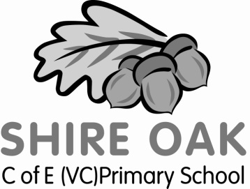
Year 5 Curriculum Newsletter

Dear Parents and Carers,

We hope that you have had an enjoyable summer holiday and would like to welcome you to Year 5. We are very much looking forward to a happy and successful year.

Our topic this term is ‘Bright Sparks’. We will be focusing on the world of inventions and the remarkable inventors who have changed the world around us. We will look at some of the early inventions right up to modern day. There will also be a mini topic centred around the human body.
Our writing will be focused around our topic which will provide plenty of stimuli for different tasks. Mathematics this term will focus on number, with an emphasis on place value and problem solving.

Staff
Adults working in Tigris class year are: myself, learning support assistants; Mrs Swiers and Miss Nicol and art specialist; Ms Virgin. There will also be volunteers and a student teacher at points during the year.

PE Lessons
PE days are on Wednesday and Thursday afternoons. Please ensure that your child has the correct PE kit in school for every lesson: White top, dark shorts, pumps and/or trainers. As the weather becomes colder, tracksuit bottoms will be appropriate as we will continue to do outdoor PE throughout the winter months. If your child trains for the rugby or football teams, they will need separate kit for this so their PE kit remains clean.

Water bottles
Please ensure that your child has a named water bottle in school. These will be filled for them every morning before school starts and the water will be changed each day.

Homework
This half-term’s homework will be given out shortly and along with the date for it to be completed by. Please remember it is still vitally important for children in Year 5 to read regularly and widely (everyday is recommended). Further to this, please take every opportunity to give your child opportunities to practice their maths passport targets, spelling and handwriting.

Finally we would like to take this opportunity to say how much we are looking forward to this very important year with your children. Please do come and see us at the first opportunity with any concerns or queries you may have. We firmly believe that your child’s education requires a partnership between home and school and we want to enable your child to achieve their very best.

Thank you.

Yours sincerely,

Mr. Davies

